**Shojib Parvez**

C:\Users\Acer\AppData\Local\Microsoft\Windows\INetCache\IE\EV59BOK4\Mobile%20Phone%20Icon[1].png +8801680341666  [spshojib1@gmail.com](mailto:spshojib1@gmail.com)

C:\Users\Acer\AppData\Local\Microsoft\Windows\INetCache\IE\0R3QIZWY\120px-Linkedin.svg[1].png <https://www.linkedin.com/in/shojib-parvez-9098a7182/>

C:\Users\Acer\AppData\Local\Microsoft\Windows\INetCache\IE\EV59BOK4\768px-F_icon.svg[1].png Facebook.com/ShojibParvez

* GP KHA-26 Shajadtpur, Gulshan-2 Dhaka-1212, Bangladesh

**CAREER OBJECTIVE**

Accomplished Sales Executive with About one years of experience in consistently promoting the brand and representing company values in all business interactions. Passionate product and industry expert and valuable business consultant with talents in analysis, judgment, knowledge of the consumer and industry dynamics. Strategic with a focus on coordinating with customers, retail partners and distribution partners to accomplish sales goals and promote the brand while maintaining strong professional relationships.

**EDUCATION**

**Bachelor of Business Administration (BBA)**

American International University-Bangladesh (2020)

Major in Marketing Current CGPA: 2.98 out off 4

**Higher Secondary School Certificate**

**(HSC)**

Dhaka Imperial College (2015)

Background: Business Study GPA : 4.25

**Secondary School Certificate (SSC)**

Gulshan Model High School (2013)

Background: Business study GPA : 4.06

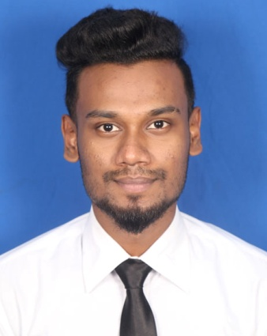

**LANGUAGES**

**Bangla C:\Users\Acer\AppData\Local\Microsoft\Windows\INetCache\IE\7908KJA8\1024px-5_stars.svg[1].png**

Native

**English C:\Users\USER\AppData\Local\Microsoft\Windows\Temporary Internet Files\Content.IE5\SXGQRXV1\1024px-3_stars.svg[1].png**

Professional

**Hindi C:\Users\USER\AppData\Local\Microsoft\Windows\Temporary Internet Files\Content.IE5\SXGQRXV1\1024px-2_stars.svg[1].png**

Professional

**ACHIEVEMENTS**

**Champion Debate competition on Global Trade (Group Leader)**

American International University-Bangladesh (2018)

**Champion New Business Idea For Attracting Foreign Investors (Group Leader)**

American International University-Bangladesh (2018)

**Volunteer Award**

American International University-Bangladesh (2017)

**2nd Runners-up Digital poster competition Biz Tech Challenge (Group Leader)**

American International University-Bangladesh (2018)

**WORK EXPERIANCE**

**Sales Executive (Safetline 2019 June – 2020 January)**

* Increased revenue by implementing effective sales strategies in all aspects of sales cycle process from prospecting leads through close.
* Analyzed past sales data and team performance to develop realistic quarterly sales goals.
* Maintained detailed records of sales progress, inventories and marketing success to better align goals with company priorities.
* Enhanced success of advertising strategies by boosting engagement through social media and other digital marketing approaches.
* Collaborated with internal teams and suppliers to evaluate costs against expected market price points and set structures to achieve profit targets.
* Led targeted training programs to educate staff on product benefits and service capabilities.
* Executed local, regional and national marketing and branding initiatives to drive sales within existing and prospective accounts.

**Strengths & Skills**

* Leadership and Team Skills
* Communication And Inter Personal skills
* Computer Skills : Excellent in Microsoft PowerPoint, Excel, Microsoft Word, Web Browsing, Adobe Photoshop
* Fluent English Speaker

**Reference**

Md. Delwar Hossain (BCS Information)

Assistant Director

Bangladesh Betar, Sylhet

Email: Haossaind42@yahoo.com

**Reference**

Dr. Sahin Akter Sarker

Associate professor of Marketing Department

American International University-Bangladesh

Email: [sasarker@aiub.edu](mailto:sasarker@aiub.edu)

**TRAINING**

**Business Opportunity in Bangladesh**

American International University-Bangladesh (2017)

Speaker: Samsung Marketing Department head

**Factory Visit**

Minister Company high-tech park Mymonshing

Speaker: DGM Minister Company

**Management Information System (MIS)**

American International University-Bangladesh (2017)

Trainer : Nahid Ahmed Faculty of MIS Department